**Report Paper**

I selected variabel ENF, ITH and IHR in the data. I use ENF (Inflation Rate) as the dependent variable. Independent variables are IHR (Export) and ITH (Import). So we will forecast the inflation rate based on predictied volume of export and import.

1. **Variables**

* Dependent variable = Inflation Rate (ENF)

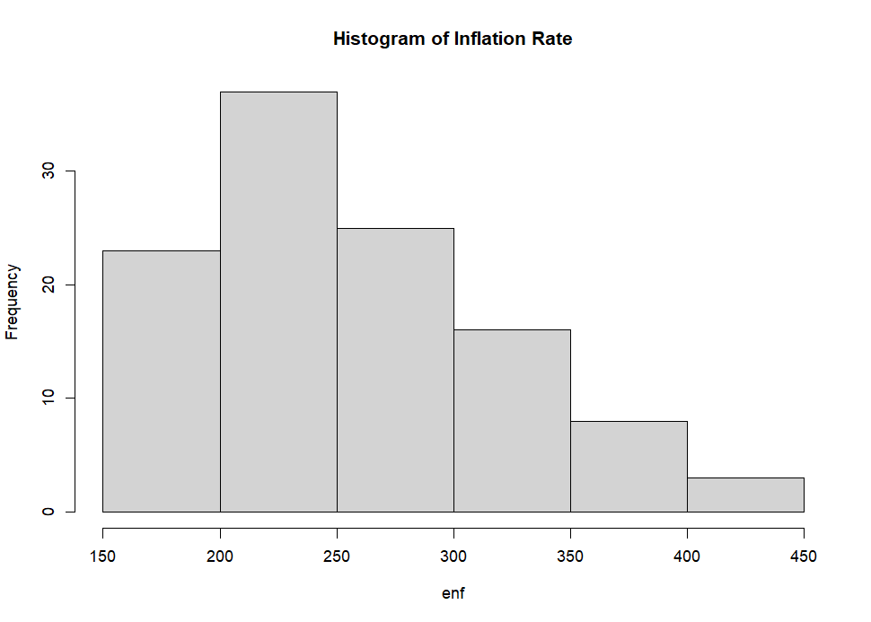

* Independent variable = Export (IHR)

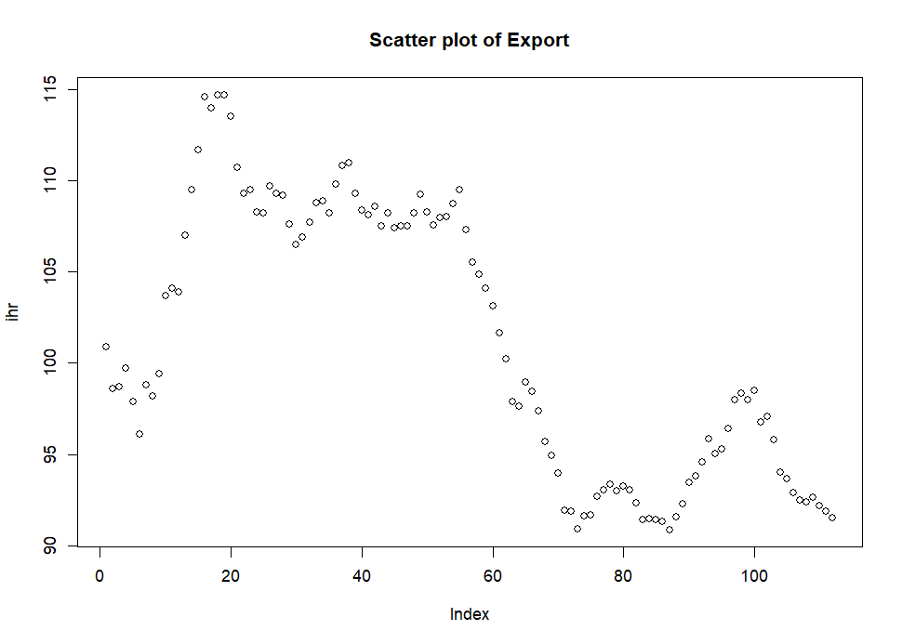

* Independent variable = Import (ITH)

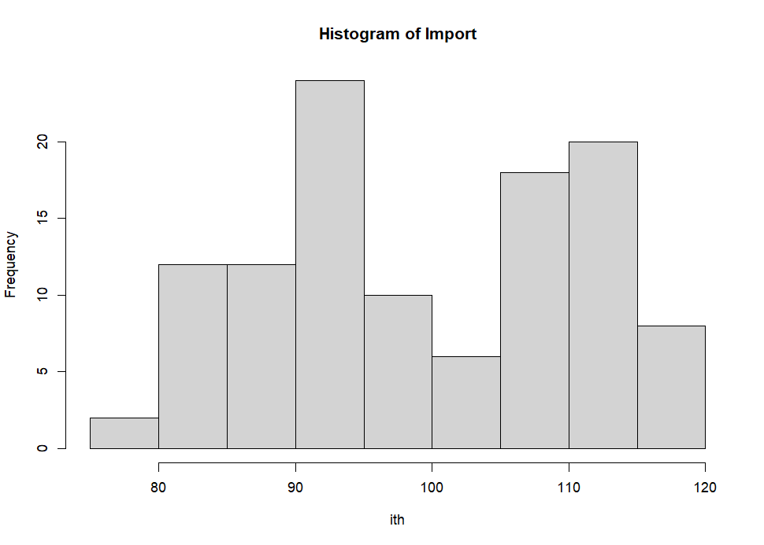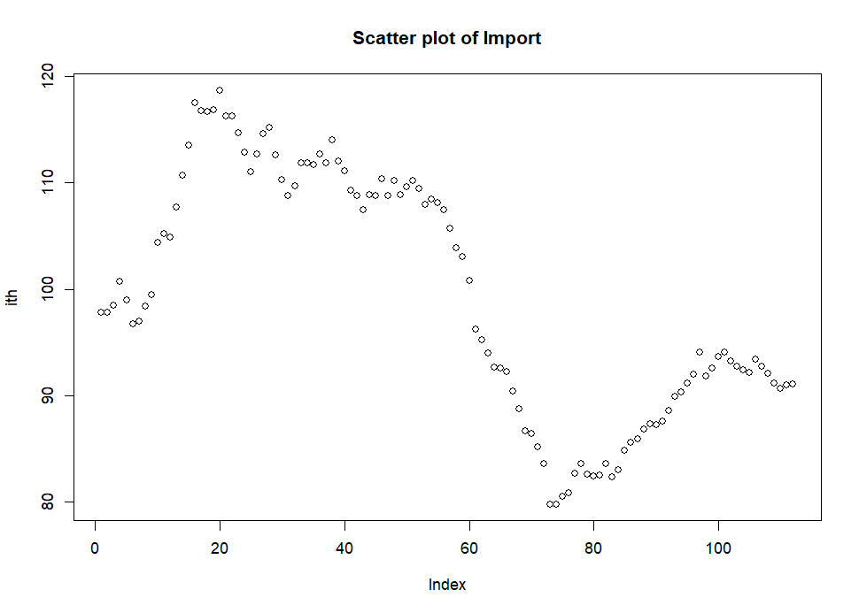

After modelling, obtained multiple linear regression :

ENF = 1021.81 -10.38*IHR + 2.86*ITH + e

Rsquared = 0.503

p-value < 0.001

The White test and the Durbin-Watson test to check heteroscedasticity and autocorrelation :

1. The White test: If p < 0.05, there is heteroscedasticity (variance is not constant)

BP value 55.255, p-value<0.001

Null hypothesis rejected 🡪 there is heteroscedasticity in the model

1. The Durbin-Watson(DW) test checks for first-order autocorrelation.

DW = 0.055, p-value < 0.001

The null hypothesis rejected 🡪 autocorrelation in the model

Conclusion = the prediction model for ENF using IHR and ITH vatiable shows a spurious regression

**Time series plot**

1. 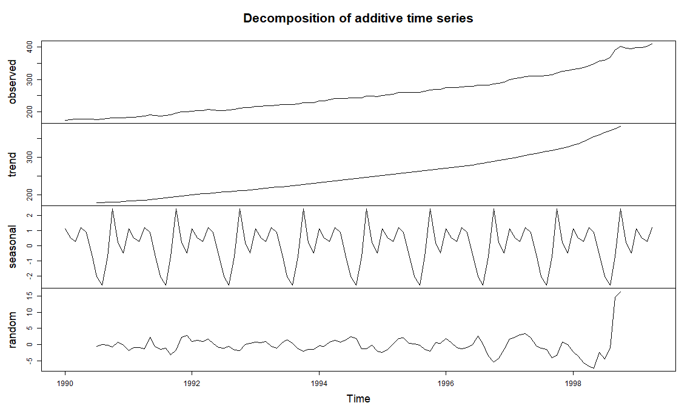Inflation Rate (ENF)

Data shows inflation rate increases from 1990 to 2000, and shows an increasing rate over time. ENF also shows seasonal pattern along the year, with random residual.

1. A graph of different types of time

   Description automatically generated with medium confidenceExport (IHR)

Data shows fluctuation in number of export, however overal it shows decreasing trend from 1990 to 2000. Seasonal trend shows several peaks in a year, meanwhile random pattern shows some noise.

1. Import (ITH)

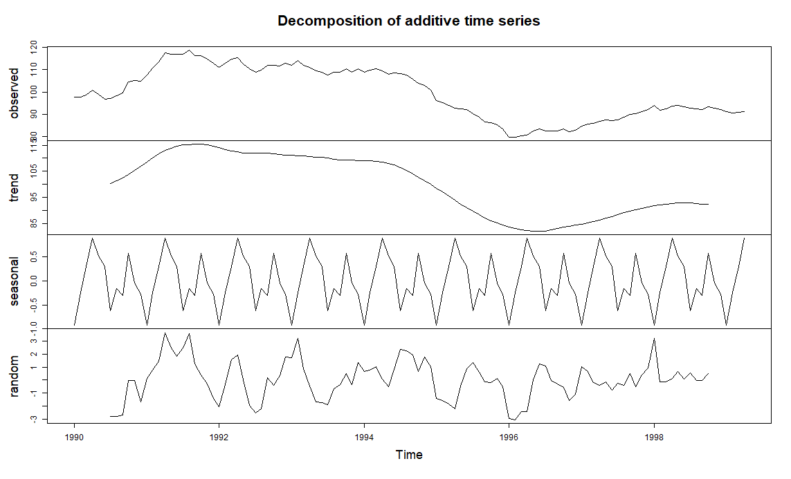

Data shows decreasing trend in volume of import, though it starts to increase later after 1998. Seasonal trend is captured each year, and shows noise in random pattern.

**Model with ARIMA**

Using ENF serie to model using ARIMA. ENF variable shows non AR-stationary in both enf and log transformation, so I use diff log enf to forecast ARIMA. Checking ACF and PACF plots, I found that diss_log10_enf variable shows some data that lag outside the range.

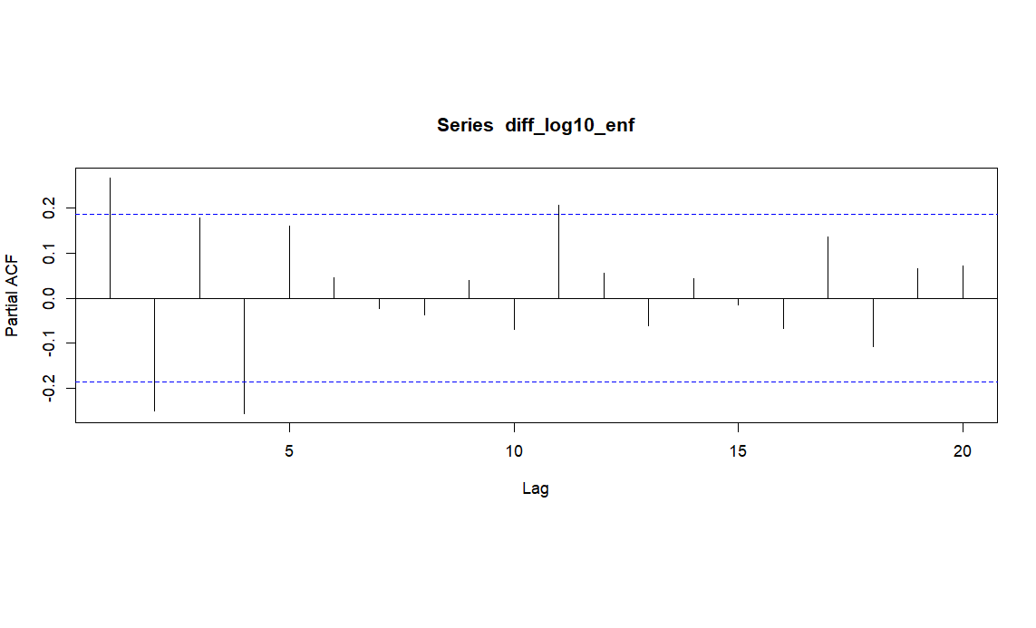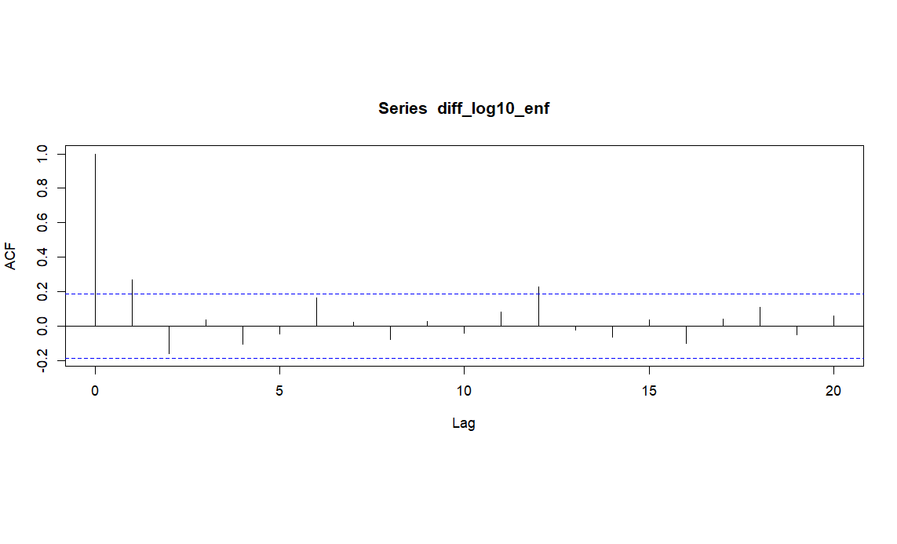

**Auto ARIMA forecast**

Forecasting inflation rate of non seasonal arima

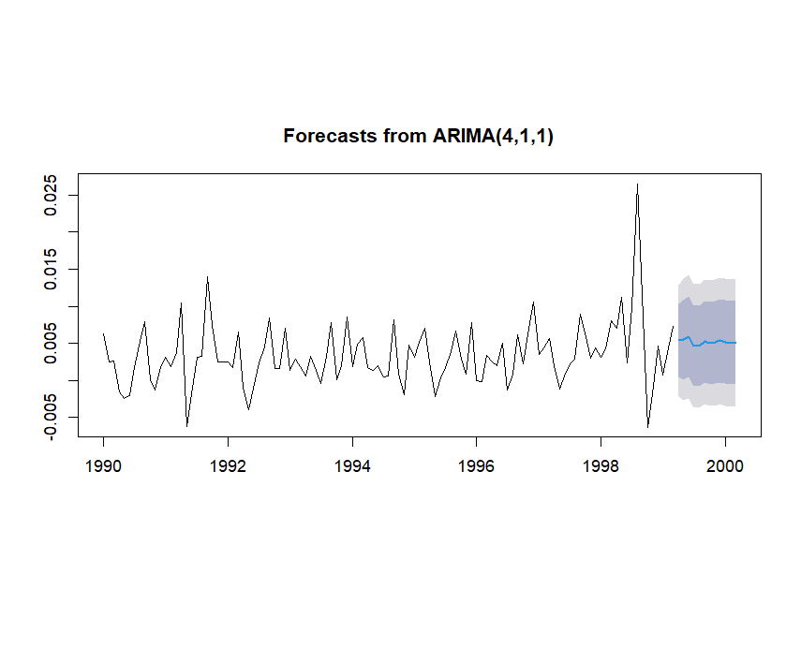

Forecasting inflation rate of seasonal arima

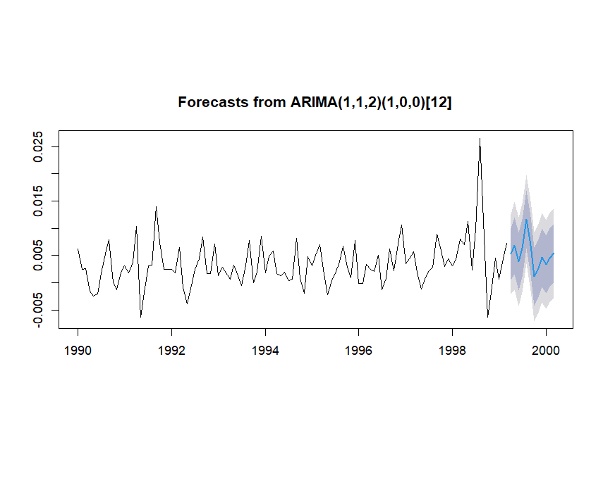

Forecasting of inflation rate shows a relatively stagnant inflation after year of 1999. However if we look at seasonal forecasting, it shows fluctuation of inflation rate that similar with previous years and peaked slightly higher just before year 2000.